Planning
This audit tool will help you review your current processes against a set of key factors that support training transfer. You will be able to use it to start to plan and prepare how your organisation can use the fostering and adoption learning resources.
The fostering and adoption learning resources, which can be accessed at http://fosteringandadoption.rip.org.uk include a range of materials that can be used to develop blended learning activities for both newly qualified and experienced social workers. The aim of this audit tool is to help you review your current processes and identify areas that you may need to address, in order to maximise the impact of the learning activities you undertake with your colleagues.
The impact of the learning resources on practice will depend on the extent to which individuals are able to transfer the skills and knowledge they have gained from the learning resources into their daily working practices. This “use of trained knowledge and skill back on the job” is referred to as ‘training transfer’ (Burke and Hutchins 2007) and occurs when “learned behaviour is generalised to the job context and maintained over time” (Baldwin & Ford 1988).
Research shows that there are a number of key factors that can impact on the effectiveness of learning and the extent to which new skills are used (Baldwin and Ford, 1988; Burke and Hutchins, 2007; Pike 2012). The key factors that have been identified are shown in Figure 1.
Figure 1. Factors that influence training transfer: (Pike (2012). Training Transfer: getting learning into practice)
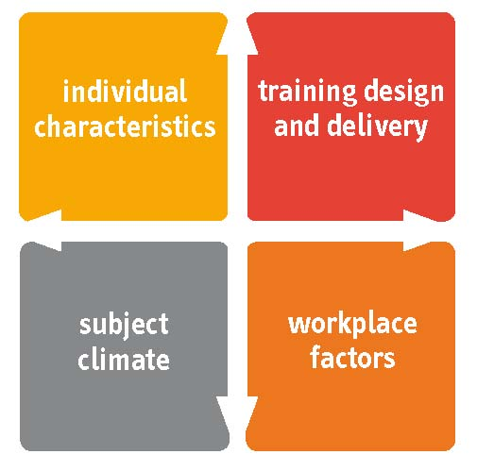
- The way the learning is designed and sequenced to provide opportunities for feedback on practice and enables delegates to develop clear action plans.

- Whether individual delegates are motivated to learn and understand how it relates to their role and the benefits it will provide.

Whether individual delegates are motivated to learn and understand how it relates to their role and the benefits it will provide.
- The level of support supervisors/managers give individuals to help them identify their needs, review their action plans and gain feedback on their performance.

- Whether individuals and teams are given opportunities to put their learning into practice and share best practice.

Areas to consider during planning
To ensure participants gain maximum value from the learning activities, you might find it helpful to assess not just the design of your planned activity, but also the individual characteristics of participants, as well as the opportunities and support they will have to put their learning into practice. This audit tool contains a series of statements for each of the factors outlined in Figure 1.

Individual characteristics
Read through each of the statements, which have been identified as key factors in ensuring that individual delegates are motivated to learn and understand how it relates to their role and the benefits it will provide. You may find it useful to talk to a number of forthcoming delegates to ask them about their experiences of previous learning activities.
- Individuals understand the importance of the subject and how it relates to their role.
- Individuals are involved in identifying their learning needs.
- Individuals are involved in setting SMART learning objectives.
- Individuals are involved in selecting activities that meet their learning styles.
- Individuals are encouraged to develop a plan that will help them build their skills in stages.
- Individuals have an opportunity to discuss the learning with their supervisor/manager before they attend.
- Individuals understand how they will be able to use the learning in their role e.g. activities, projects.
- Individuals understand how their learning will be reviewed.

Then ask yourself the following questions about the learning activity you intend to deliver/facilitate in your organisation:
To what extent do your current processes ensure that these factors are addressed?
What actions can you take to ensure these factors are addressed for the fostering and adoption learning resources?
Which key stakeholders do you need to involve?
How can you gain these stakeholders’ support?

Training design and delivery
Read through each of the statements, which have been identified as key factors in ensuring that learning is designed and sequenced to provide opportunities for feedback on practice and enables delegates to develop clear action plans. Then think about the learning activity you are planning within your organisation and answer the questions below.
- Learning outcomes are identified and clearly communicated for every learning activity.
- Learning activities are designed to help individuals build their skills in stages.
- Learning activities use a variety of methods to meet different learning styles.
- Learning activities provide opportunities to practise using skills and gain constructive feedback.
- Links are made between the skills/knowledge covered during the learning and the processes/systems that are used in the organisation.
- Learning activities are supported by action plans and learning logs to help individuals use the skills in their daily working practices.
- Impact and evaluation measurements are built into the learning activities.
- Learning activities are reviewed and refined to address individuals’ needs.

To what extent do your current processes ensure that these factors are addressed?

What actions can you take to ensure these factors are addressed for the fostering and adoption learning resources?

Which key stakeholders do you need to involve?

How can you gain these stakeholders’ support?

Workplace factors
Read through each of the statements, which have been identified as key factors in ensuring that supervisors/managers help individuals identify their needs, review their action plans and gain feedback on their performance. You may find it useful to talk to a number of supervisors/managers to help you answer them. Then think about the learning activity you are planning within your organisation and answer the questions below.
- Supervisors/managers are involved in identifying learning needs and agreeing learning goals for their teams.
- Supervisors/managers help individuals identify SMART learning objectives.
- Supervisors/managers review learning with individuals during supervisory meetings.
- Supervisors/managers give individuals opportunities to practise using the skills/knowledge they have gained.
- Supervisors/managers create opportunities to discuss and share best practice and learning during team meetings.
- Learning is reinforced through coaching and supervisory support.

To what extent do supervisors/managers ensure that these factors are addressed?
What support can you provide supervisors/managers to ensure these factors are addressed for the fostering and adoption learning resources?
Which key stakeholders do you need to involve?
How can you gain these stakeholders’ support?

Subject climate
Read through each of the statements, which have been identified as key factors in ensuring that individuals and teams are given opportunities to put their learning into practice and share best practice. You may find it useful to talk to a number of supervisors / managers to help you answer them. Then think about the learning activity you are planning within your organisation and answer the questions below.
- Supervisors/managers receive guidance on how to make links between the skills/ knowledge covered during the learning and the processes/systems that are used in their department.
- Supervisors/managers and other senior figures lead by example.
- Individuals are encouraged to be open to new ideas and share best practice with team members.
- Individuals receive constructive feedback on their practice and performance.
- Teams are encouraged to suggest ways that practice and performance can be continuously improved.
- Teams are encouraged to set joint goals to support the introduction of new skills and methods.

To what extent do supervisors/managers and senior managers ensure that these factors are addressed?

What support can you provide to ensure these factors are addressed for the fostering and adoption learning resources?

Which key stakeholders do you need to involve?

How can you gain these stakeholders’ support?

Burke LA and Hutchins HM (2007) “Training Transfer: An integrative literature review” Human Resource Development Review 6 (3) 263-296
Baldwin and Ford (1988)
Pike (2012). Training Transfer: getting learning into practice

