**Identifying learning and development needs**

You can use the questions in the diagram below to start to think about your learning and development needs. Figure 1[1]. Identifying learning and development needs.

4 What have you achieved?

* To what extent have you achieved your learning objectives?
* What can you do differently?
* What difference has that made to your role?
* What else do you need to learn or practise?
* What additional support do you need?

2 How do you prefer to learn?

* What type of activities will help you learn the new skills/knowledge?
* How will you be able to practise using the new skills/knowledge?
* What support will you need to use the new skills/knowledge?

1 What do you need to do?

* What skills or knowledge would you like to improve?
* What will you be able to do more effectively if you develop these skills or knowledge?
* How will you be able to demonstrate this?

3 How will you measure your progress?

* When will you start?
* How will you review what you’ve learnt?
* How will you apply the learning to your role?
* Who will be able to give you feedback to help you review your progress?
* How will you measure your progress?

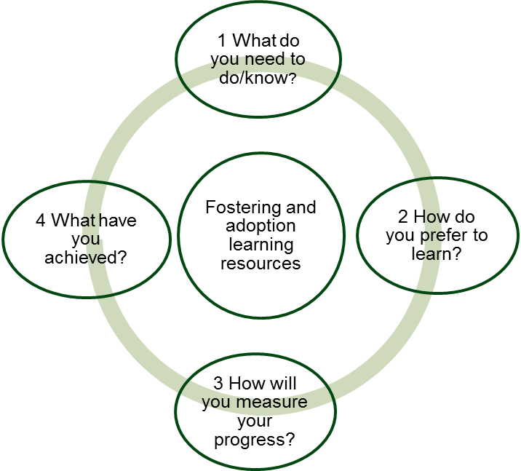

**Setting SMART learning objectives**

Learning objectives are specific statements that describe what you will be able to do as a result of their learning. SMART learning objectives include:

|  |  |
| --- | --- |
| **S**pecific | What do you need to know, be able to do or improve? |
| **M**easurable | What will you know or be able to do differently?  How will you be able to demonstrate this?  How will you be able to measure your progress? |
| **A**chievable | Is the objective feasible in the timescale? Complex skills can take time to develop and practise, you may find it useful to break your objective down into stages and set yourself milestones that describe what will you be able to do after 3, 6 or 9 months.  What support do you need from your supervisor/manager to achieve your objective?  What opportunities will you need in order to practise using the skills in your role? |
| **R**elevant | How will this skill/knowledge help you in your current role?  What aspects of your role will it improve/support? |
| **T**ime-framed | Include clear milestones and review dates. |

1. Wilkinson K, Pike L and Halliday J (2013) Evaluating Training Impact: a Guide from reason (Doing – Research and Evaluation: Planning). Dartington: reason Adapted